- Long-stemmed pea plants were crossed with short-stemmed pea plants. All the offspring
were long-stemmed plants

The genotypes of the offspring plants are:
  - either homozygous dominant or heterozygous
  - heterozygous only
  - homozygous dominant only
  - homozygous recessive only

- Recombination occurs during:
  - anaphase of the second meiotic division, as chromosomes separate
  - metaphase of the first meiotic division, as chromosomes are paired
  - interphase as chromosomes are replicated
  - telophase of the first meiotic division, when cytoplasm is divided into two parts

- Which of the following is NOT a significant source of variation in humans?
  - Random fertilization
  - DNA replication
  - Recombination
  - Non-identical parents

- Fragile-X syndrome is caused by a single gene defect of the FMR1 gene on the X chromosome, causing mental retardation.

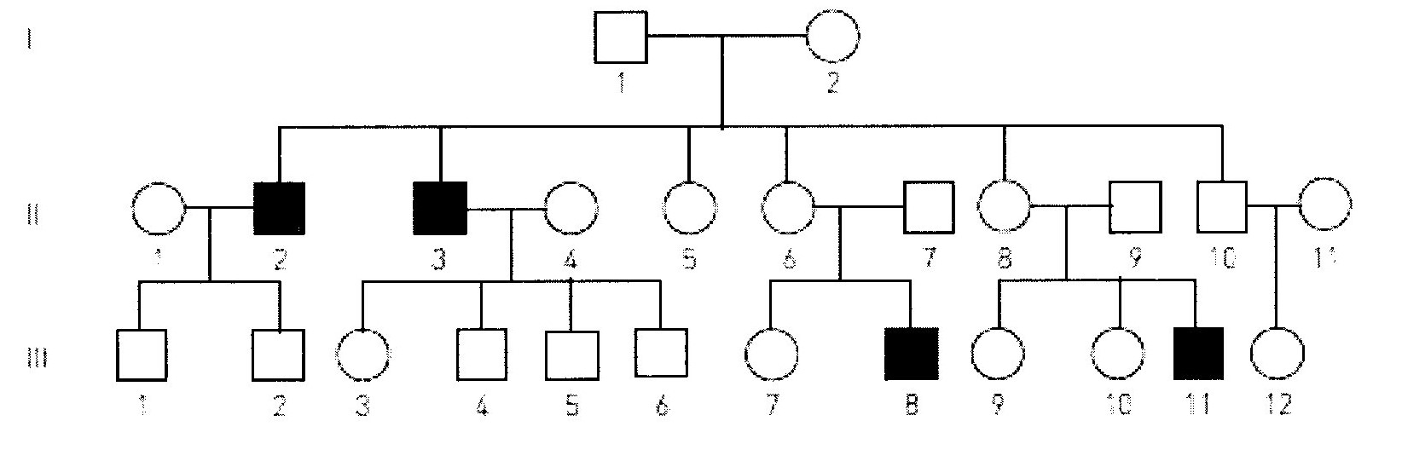

Using the pedigree shown, which one of the following combinations of genotypes is possible for the individuals listed?

  - I 2: X^{F} X^{f}, II 4: X^{F} X^{f}, III 6: X^{F} Y

  - I 2: X^{F} X^{f}, II 4: X^{F} X^{F}, III 6: X^{f} Y

  - I 2: X^{F} X^{F}, II 4: X^{F} X^{F}, III 6: X^{F} Y

  - I 2: X^{f} X^{f} II 4: X^{F} X^{f}, III 6: X^{f} Y

- In regards to sex determination, which statement is correct?

  - A zygote with X and Y chromosomes will develop into a female.
  - Two X chromosome ova can fuse to develop into a female with XX chromosomes.
  - Half of all ova have X chromosomes, while the other half have Y chromosomes.
  - Half of all sperm have X chromosomes, while the other half have Y chromosomes.

- A haemophiliac man and a non-haemophiliac woman, who comes from a family with no history of haemophilia, have a daughter.
Which probability matches this circumstance?

  - There is a 50% chance the daughter has haemophilia
  - There is a 100% chance the daughter is a carrier
  - There is a 50% chance the daughter is homozygous dominant
  - There is a 100% chance the daughter is homozygous recessive.

- Non-disjunction producing non-haploid gametes can occur during:

  - the first or second meiotic division.
  - The first meiotic division only.
  - the second meiotic division only
  - mitotic division

- Fertilization by any particular sperm is:

  - irrelevant because they will all have identical chromosomes.
  - dependant on chromosomes matching
  - controlled by the ovum
  - random.

- Fragile-X syndrome is caused by a single gene defect of the FMR1 gene on the X chromosome causing mental retardation.



From the pedigree above, what is the probability that individual II 5 is a carrier of Fragile-X syndrome?

a. 0
b. 1
c. ½
d. ¼

- One type of colour blindness is determined by a gene on the X chromosome.
Which of the following lists all the possible genotypes that could result from a cross between individuals with the genotypes X^{b} Y and X^{B} X^{b}?

a. X^{B} Y, X^{b} Y, X^{B} X^{B}, X^{B} X^{b}

b. X^{B} Y, X^{b} Y, X^{B} X^{B}

c. X^{B} Y^{b}, X^{b}Y, X^{B} X^{b}, X^{B} X^{B}

d. X^{B} Y, X^{b} Y, X^{B} X^{b}, X^{b} X^{b}

- Two parents who are not albino have one child that is albino. The probability that a second child would be albino is:

a. 25%
b. 50%
c. 0%
d. 100%

- A father with blood type A and a mother with blood type O have children.
The blood types of these children may be:

a. A
b. O
c. A or O
d. A or B

SHORT ANSWER

Write the correct term for the meanings written in the table below.
No. | MEANING | TERMINOLOGY
1 | Produce the same characteristic in succeeding generations when bred among themselves
2 | the mating of two organisms – in genetics
3 | the situation where an individual has the same allele for a particular characteristic
4 | gel electrophoresis is used to make a genetic….
5 | A male gets his Y chromosome from his…?
6 | Huntington’s disease shows this type of inheritance…
7 | Differences between members of a species are called…
8 | Surname of a British geneticist who devised a square to help with his work on heredity.
9 | A non-sex chromosome
10 | Where a person has only one copy of a chromosome, where normally there would be two

11. This diagram represents changes in the numbers of chromosomes during reproduction and growth.

Parents 2n 2n

(x)

Gametes
n n

Zygote (y)

2n

(z)

2n

a. What does 2n represent? __________________________________________________

b. What does n represent? __________________________________________________

c. Identify the process: (x) ____________________________________________________

(y) ____________________________________________________

(z) ____________________________________________________

12. A woman of blood group A claims that a man of blood group AB is the father of her child. A blood test reveals that the child’s blood group is O.

a. Is it possible the woman’s claim is correct? Show working

b. Could the father of the child have been a group B man? Explain your reasoning.

_____________________________________________________________________________
_____________________________________________________________________________

13. A woman is heterozygous for a sex-linked recessive characteristic. She has children with a man who has the characteristic. What will be the proportion of the genotypes and phenotypes in their offspring?
Show all working

SECTION C – EXTENDED RESPONSE

14. a. Describe three inheritance processes which introduce variation into a species. (15 marks)

__________________________________________________________________________________________________________________________________________________________________________________________________________________________________________________________________________________________________________________________________________________________________________________________________________________________________________________________________________________________________________________________________________________________________________________________________________________________________________________________________________________________________________________________________________________________________________________________________________________________________________________________________________________________________________________________________________________________________________________________________________________________________________________________________________________________________________________________________________________________________________________________________________________________________________________________________________________________________________________________________________________________________________________________________________________________________________________________________________________________________________________________________________________________________________________________________________________________________________________________________________________________________________________________________________________________________________________________________________________________________________________________________________________________________________________________________________________________________________________________________________________________________________________________________________________________________________________________________________________________________________________________________________________________________________________________________________________________________________________________________________________________________________________________________________________________________________________________________________________________________________________________________________________________________________________________________________________________________________________________________________________________________________________________________________________________________________________________________________________________________________________________________________________________________________________________________________________________________________________________________________________________________

